National ESEA Distinguished Schools Award:

Let the good times roll seems to be a trend around here these days as Davenport Middle School and High School has been recognized again this year for its outstanding academic achievement!
Dear Principal Prewitt,
Congratulations! Your school has been selected by your state for national recognition because of the success of your educational programs and progress made by your students.
Each state may only name two schools as National EAEA Distinguished Schools per year, so this is an especially prestigious honor. We’ve developed a brief brochure to provide you with more details on what this means to your school. (Attached is the Brochure)
Educational Programs & a brief trip Down Memory Lane!
Washington State Achievement Awards: 2014, 2015, 2016, 2017
School of Distinction: 2015, 2017, 2018
National ESEA Distinguished School & National Blue-Ribbon School of Excellence: 2019
Why are we winning all these awards? What are you doing to help students achieve at high levels?
These are questions that I have been getting a lot lately and I always say it is because of our incredible CULTURE, we have an amazing staff that consistently goes above and beyond to help our students succeed. “The school’s culture dictates, in no uncertain terms, the way we do things around here.” – Roland Barth
Response to Intervention (RTI): 2012-2013 (How will we respond when some students do not learn it?)
RTI was implemented during the 2012-2013 school year. This program is designed to target specific students in need of intervention. The 20-minute period that is still in place today and targets students in need of intervention or enrichment (Advanced Placement).
Professional Learning Communities (PLC’s): 2013-2014 (4 Critical Questions)
- What do we want all students to know and be able to do?
- How will we know if they learn it?
- How will we respond when some students do not learn it?
- How will we extend the learning for students who are already proficient?

PLC & Diving into the Standards:
We are making a concerted effort in our PLC’s this year to audit and calibrate what we are doing as a staff to ensure that our students are getting grade level material, that meets the rigorous standards and expectations so they can take advantage of their education. In October, teams will be bringing student evidence to share with one another. Below is a picture of the ELA, CTE, and S.S. team in action, they are reviewing standards and setting goals for our students! This is a big part of why we are out pacing the state, that one-hour every Monday allows our teachers to collaborate to be better for our students.
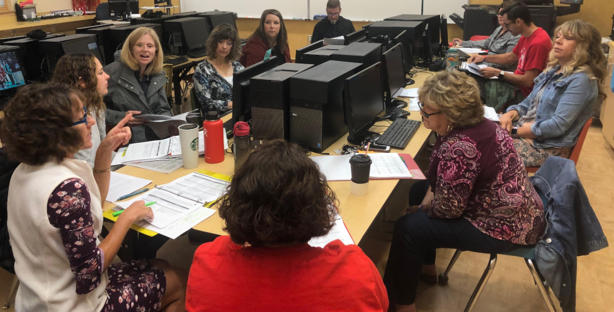
After-School Studies & New Athletic Code (Emphasis on Math): 2014-2015
We implemented after-school studies and reformatted the academic side our athletic code. Any students who are below a 2.0 or have a D or below in any class are required to attend after-school studies. The emphasis is on math, our employees in these positions must take a math proficiency assessment before they are recommended for hire. Our very first math intervention aide was Mr. Justin Young. Mrs. Vesnekse took over the position from him and transformed it into what it looks like today. Currently, Mrs. Choate and Mrs. Slahtasky serve in these positions at the MS & HS respectively. They lovingly track down students with missing assignments, encourage after-school studies attendance, help in math classrooms, and pull students from P.E. who need a little extra time and support.
College in the High School (College Credit) & Increase Advanced Placement Offerings:
Implemented College in the High School and increased the number of Advanced Placement offerings. Most students are graduating with almost 49 college credits by the time they leave Davenport High School.
Addition of Support Classes:
Mrs. Ragust, Mrs. Graham, and Mrs. Hargrave have added support classes to their schedules. This is another intervention program that targets students in need to attritional support which is in addition to our RTI program.
Project Lead the Way (PLTW):
Increase in STEM (Science, Technology, Engineering, & Math) courses at DMS & DHS. Helps students engage in relevant and hands on materials.
Lincoln County Tech: Satellite Skill Center
These are just some of the educational programs that you as a school board have supported over the years. It is truly the way we do things around here! We believe in creating endless possibilities for every student, every day! Our staff makes it their personal mission to make learning at high levels a top priority in our district. We know there are going to be trying times ahead and that we can always improve, but if anyone asks why we are doing so well, I hope this helps! OUR Culture drives these programs and it would not be possible without your unwavering support. THANK YOU!

