Mr. Kowalkowski and I are recommending we keep all three levies at their approved rates for 2020, and run an Enrichment (EPO) Levy and a Capital Projects Levy for four years, beginning in 2021. See below for the amounts we would generate with each. I also included the example of lowering the transportation vehicle levy at the .25/$1,000 that we discussed in October.
Leslie Oliver

Estimated levy rates for 2020 and for the four-year levy
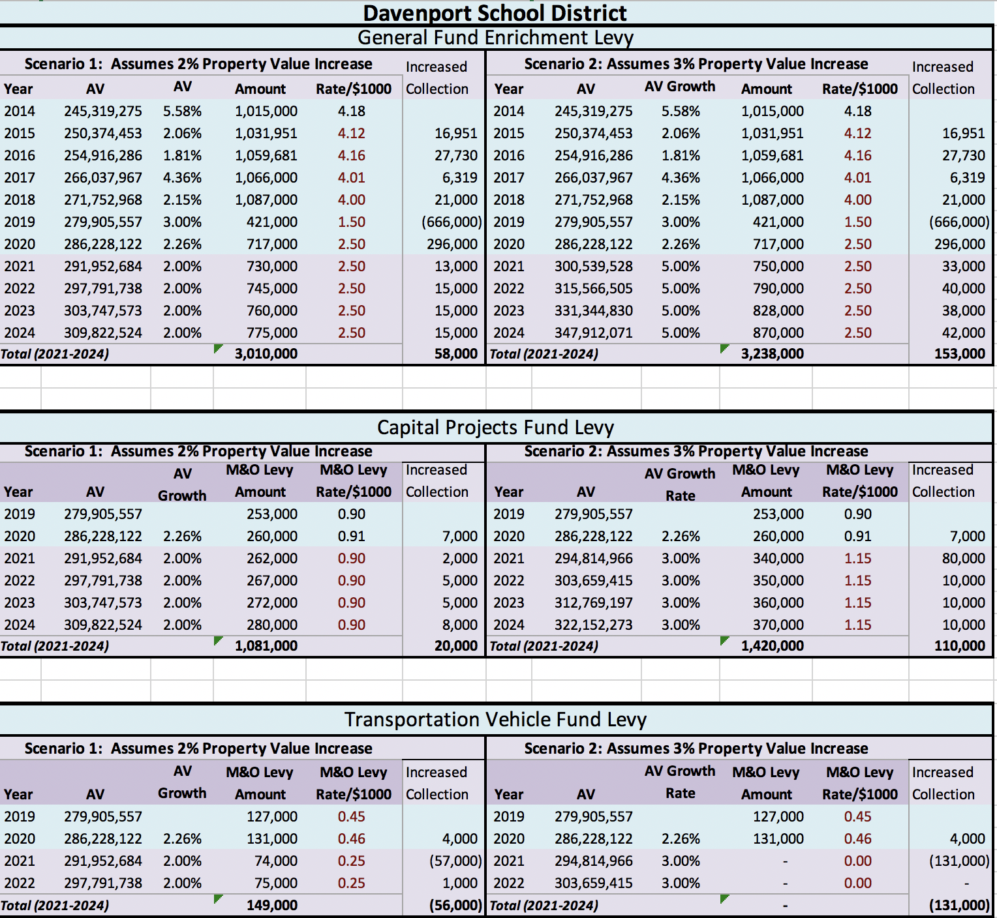

Estimates with keeping the TVF levy for 2020 only.
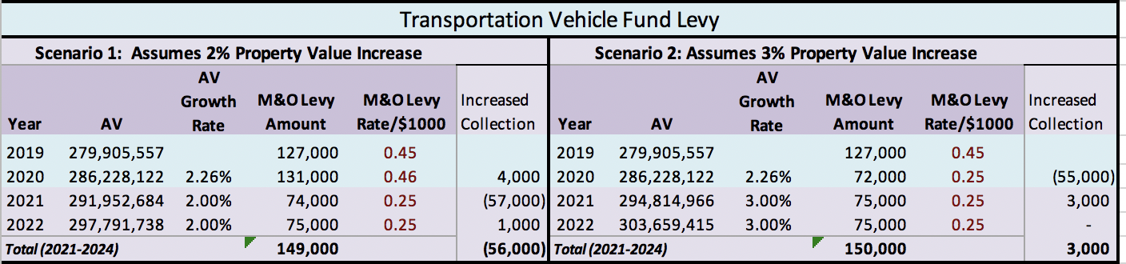

This graph shows the total tax rate including the State tax rate and without renewing the transportation vehicle levy. I estimated increasing the capital projects levy to $1.15/$1,000 starting in 2021, but we can discuss options for the 2021-2024 levy rates at the December 9th meeting.

